Magnetism - 01
CLASS 10 - SCIENCE

 | Section A
1 | Read the text carefully and answer the questions: A student fixes a sheet of white paper on a drawing board using some adhesive materials. She places a bar magnet in the centre of it and sprinkles some iron filings uniformly around the bar magnet using a salt - sprinkler. On tapping the board gently, she observes that the iron filings have arranged themselves in a particular pattern.  - Draw a diagram to show this pattern of iron filings.  - Draw the magnetic field lines of a bar magnet showing the poles of the bar magnet as well as the direction of the magnetic field lines.  - How is the direction of magnetic field at a point determined using the field lines? Why do two magnetic field lines not cross each other?  - How are the magnetic field lines of a bar magnet drawn using a small compass needle? Draw one magnetic field line each on both sides of the magnet. | [4]
2 | Read the text carefully and answer the questions: Andre Marie Ampere suggested that a magnet must exert an equal and opposite force on a current - carrying conductor, which was experimentally found to be true. But we know that current is due to charges in motion. Thus, it is clear that a charge moving in a magnetic field experience a force, except when it is moving in a direction parallel to it. If the direction of motion is perpendicular to the direction of magnetic field, the magnitude of force experienced depends on the charge, velocity (v), strength of magnetic field (B), and sine of the angle between v and B. Direction of magnetic force is given by Fleming’s left - hand rule. 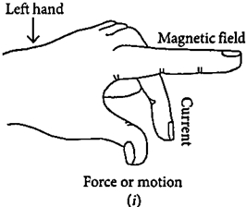  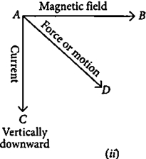  - If an electron is travelling horizontally towards east. A magnetic field in vertically downward direction exerts a force on the electron along which direction?  - A charged particle is moving with velocity v in a magnetic field of induction B. The force on the particle will be maximum when  - A uniform magnetic field exists in the plane of paper pointing from left to right as shown in figure. In the field, an electron and a proton move as shown. Where do theelectron and the proton experience the force? 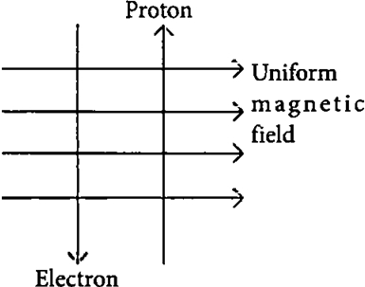  - An electron beam enters a magnetic field at right angles to it as shown in the figure. What would be the direction of force acting on the electron beam? 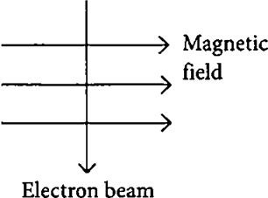 | [4]
3 | Read the text carefully and answer the questions: A student fixes a sheet of white paper on a drawing board using some adhesive materials. She places a bar magnet in the centre of it and sprinkles some iron filings uniformly around the bar magnet using a salt sprinkler. On tapping the board gently , she observes that the iron filings have arranged themselves in a particular pattern.  - What makes iron filings arrange in a definite pattern?  - Draw a diagram to show this pattern of iron filings.  - How is the direction of magnetic field at a point determined using the field lines? Why do two magnetic field lines not cross each other?  - How are the magnetic field lines of a bar magnet drawn using a small compass needle? Draw one magnetic field line each on both sides of the magnet. | [4]
4 | Read the text carefully and answer the questions: A student fixes a sheet of white paper on a drawing board using some adhesive materials. She places a bar magnet in the centre of it and sprinkles some iron filings uniformly around the bar magnet using a salt sprinkler. On tapping the board gently, she observes that the iron filings have arranged themselves in a particular pattern.  - What does this pattern of iron filings demonstrate?  - Draw a diagram to show this pattern of iron filings.  - How is the direction of the magnetic field at a point determined using the field lines? Why do two magnetic field lines not cross each other?  - How are the magnetic field lines of a bar magnet drawn using a small compass needle ? Draw one magnetic field line each on both sides of the magnet. | [4]
5 | Read the text carefully and answer the questions: A student was asked to perform an experiment to study the force on a current carrying conductor in a magnetic field. He took a small aluminum rod AB, a strong horse shoe magnet, some connecting wires , a battery and a switch and connected them as shown. He observed that on passing current, the rod gets displaced. On reversing the direction of current, the direction of displacement also gets reversed. On the basis of your understanding of this phenomenon, answer the following questions: 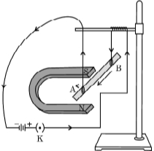  - In the above experimented set up, when current is passed through the rod, it gets displaced towards the left. What will happen to the displacement if the polarity of the magnet and the direction of current both are reversed?  - Name any two devices that use current carrying conductors and magnetic field.  - Why does the rod get displaced on passing a current through it?  - State the rule that determines the direction of the force on the conductor AB.  - Draw the pattern of magnetic field lines produced around a current carrying straight conductor held vertically on a horizontal cardboard. Indicate the direction of the field lines as well as the direction of current flowing through the conductor. | [4]
6 | Read the text carefully and answer the questions: A student was asked to perform an experiment to study the force on a current carrying conductor in a magnetic field. He took a small aluminum rod AB, a strong horse shoe magnet, some connecting wires, a battery and a switch and connected them as shown. He observed that on passing current, the rod gets displaced. On reversing the direction of current, the direction of displacement also gets reversed. On the basis of your understanding of this phenomenon, answer the following questions:   - Why does the rod get displaced on passing current through it?  - State the rule that determines the direction of the force on the conductor AB.  - If the U shaped magnet is held vertically and the aluminum rod is suspended horizontally with its end B towards due north, then on passing current through the rod from B to A as shown, in which direction will the rod be displaced?  - Name any two devices that use current carrying conductors and magnetic field.  - Draw the pattern of magnetic field lines produced around a current carrying straight conductor held vertically on a horizontal cardboard. Indicate the direction of the field lines as well as the direction of current flowing through the conductor. | [4]
7 | Read the text carefully and answer the questions: Take two different coils of copper wire having large number of turns, say 50 and 100 turns respectively. Insert them over a non - conducting roll as shown in the given figure. Connect the Coil - 1, having large number of turns, in series with a battery and a plug key. Also connect the other Coil - 2 with a galvanometer. 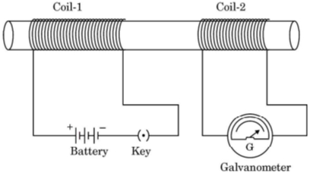  - Explain the reason for the current which is responsible for the deflection in the galvanometer.  - Define the phenomenon involved in this case.  - State what is observed in the galvanometer, when  - the key is closed.  - the key is opened.  - A coil AB of copper wire is connected to a galvanometer as shown in the figure. What is observed when N - pole of a strong bar magnet is 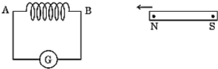  - pushed into the coil?  - held stationary inside the coil?  - State the reason for each observation. | [4]
8 | Read the text carefully and answer the questions: An insulated copper wire wound on a cylindrical cardboard tube such that its length is greater than its diameter is called a solenoid. When an electric current is passed through the solenoid, it produces a magnetic field around it. The magnetic field produced by a current - carrying solenoid is similar to the magnetic field produced by a bar magnet. The field lines inside the solenoid are in the form of parallel straight lines. The strong magnetic field produced inside a current - carrying solenoid can be used to magnetize a piece of a magnetic material like soft iron when placed inside the solenoid. The strength of the magnetic field produced by a current - carrying solenoid is directly proportional to the number of turns and strength of the current in the solenoid. 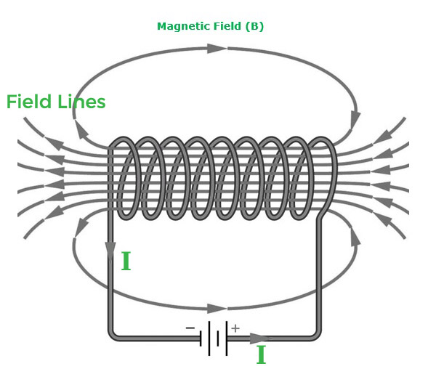  - What would be the strength of the magnetic field inside a long current - carrying straight solenoid?  - Which end is north and which end is south pole when current flows through a solenoid?  - A long solenoid carrying a current produces a magnetic field B along its axis. If the current is double and the number of turns per cm is halved, then what will be the new value of the magnetic field?  - ​​​​​​​ A soft iron bar is enclosed by a coil of insulated copper wire as shown in the figure. When the plug of the key is closed, then where would the face B of the iron bar be marked? 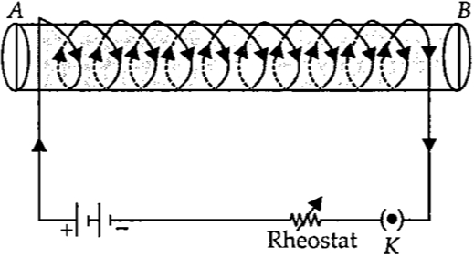 | [4]
9 | Read the text carefully and answer the questions: A student was asked to perform an experiment to study the force on a current carrying conductor in a magnetic field. He took a small aluminum rod AB, a strong horse shoe magnet, some connecting wires, a battery and a switch and connected them as shown. He observed that on passing current, the rod gets displaced. On reversing the direction of current, the direction of displacement also gets reversed. On the basis of your understanding of this phenomenon, answer the following questions :   - State the condition under which the displacement of the rod is largest for the same magnitude of current flowing through it.  - State the rule that determines the direction of the force on the conductor AB.  - If the U shaped magnet is held vertically and the aluminum rod is suspended horizontally with its end B towards due north, then on passing current through the rod from B to A as shown, in which direction will the rod be displaced?  - Name any two devices that use current carrying conductors and magnetic field.  - Draw the pattern of magnetic field lines produced around a current - carrying straight conductor held vertically on horizontal cardboard. Indicate the direction of the field lines as well as the direction of the current flowing through the conductor. | [4]
10 | Read the text carefully and answer the questions: A magnetic field is described by drawing the magnetic field lines. When a small north magnetic pole is placed in the magnetic field created by a magnet, it will experience a force. And if the north pole is free, it will move under the influence of the magnetic field. The path traced by a north magnetic pole free to move under the influence of a magnetic field is called a magnetic field line. 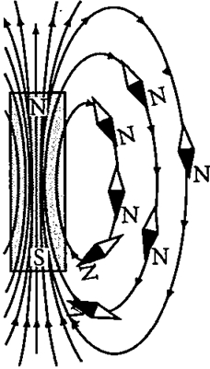  Since the direction of the magnetic field line is the direction of the force on a north pole, so the magnetic field lines always begin from the N - pole of a magnet and end on the S - pole of the magnet. Inside the magnet, however, the direction of magnetic field lines is from the S - pole of the magnet to the N - pole of the magnet. Thus, the magnetic field lines are closed curves. When a small compass is moved along a magnetic field line, the compass needle always sets itself along the line tangential to it. So, a line drawn from the south pole of the compass needle to its north pole indicates the direction of the magnetic field at that point.  - Do the magnetic field lines intersect? if not why?  - A strong bar magnet is placed vertically above a horizontal wooden board. What would be the magnetic lines of force?  - The figure shows the magnetic field lines in a magnetic field. A, B., and C are three points in this field. At what point is the magnetic field strength?​​​​​​ 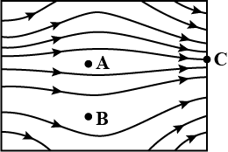  - Draw the pattern of magnetic field lines for a bar magnet. | [4]
 | Section B
11 | A plotting compass is placed inside a solenoid and the compass needle is pointing in the direction as shown. 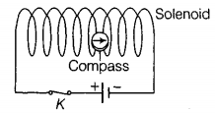  - Complete the diagram by drawing arrowheads to indicate the direction of the current flow.  - Describe the direction of the magnetic field inside the solenoid. | [3]
12 | - A horizontal power line carries a current from East to West direction. What is the direction of the magnetic field due to the current in the power line at a point above and below the power line?  - Two circular coils X and Y are placed close to each other. If the current in coil X is changed then some current will be induced in coil Y? Give reason.  - State Fleming’s right - hand rule. | [3]
13 | AB is a current carrying conductor in the plane of the paper as shown in Figure. 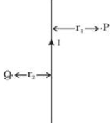  - What are the directions of magnetic fields produced by it at points P and Q?  - Given r$​_{1}$ > r $​_{2}$ , where will the strength of the magnetic field be larger? | [3]
14 | A circular metallic loop is kept above the wire AB as shown below: 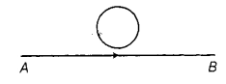  What is the direction of induced current produced in the loop, if the current flowing in the straight wire  - is steady, i.e. does not vary?  - is increasing in magnitude? | [3]
15 | - State the rule to determine the direction of a  - magnetic field produced around a straight conductor carrying current  - force experienced by a current - carrying straight conductor placed in a magnetic field which is perpendicular to it, and  - current induced in a coil due to its rotation in a magnetic field.  - State the purpose for which the following rules are used  - Right hand thumb rule  - Fleming’s left hand rule  - Fleming’s right hand rule | [3]
16 | - Imagine that you are sitting in a chamber with your back to one wall. An electron beam, moving horizontally from back wall towards the front wall, is deflected by a strong magnetic field to your right side. What is the direction of magnetic field?  - Two circular coils A and B placed closed to each other. If the current in the coil A is changed, will some current be induced in coil B? Give reason. | [3]
17 | A circuit contains a battery, a variable resistor and a solenoid. The figure below shows the magnetic field pattern produced by the current in the solenoid. 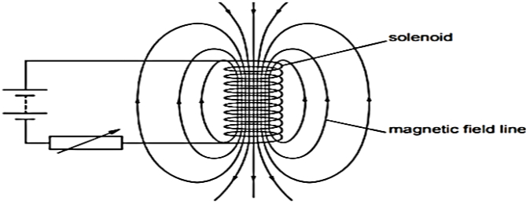  - State how the magnetic field pattern indicates regions where the magnetic field is stronger.  - What happens to the magnetic field when the current in the circuit is reversed? | [3]
18 | The wire in the figure below is being moved downwards through the magnetic field, so as to produce induced current. 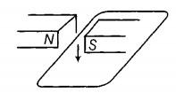  What would be the effect of  - moving the wire at a higher speed?  - moving the wire upwards rather than downwards? | [3]
19 | We know a current - carrying conductor placed in a magnetic field experiences a force due to which the conductor moves. How do we think the conductor displaces if - 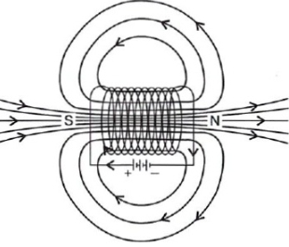  - current in a conductor is increased.  - a stronger horse shoe is inserted. | [3]
20 | - An electron beam is moving vertically upwards if it passes through a magnetic field which is directed from south to north in a horizontal plane then in which direction will the beam be deflected?  - What is the force experienced by a wire carrying a current of 10 A of 10m length placed in a uniform magnetic field of 25 Tesla in a direction parallel to the wire? | [3]
21 | - Why does a magnetic compass needle pointing North and South in the absence of a nearby magnet get deflected when a bar magnet or a current - carrying loop is brought near it. Describe some salient features of magnetic lines of field concept.  - Describe the activity that shows that a current - carrying conductor experiences a force perpendicular to its length and the external magnetic field. How does Fleming’s left - hand rule help us to find the direction of the force acting on the current - carrying conductor? | [3]
22 | The wire in the figure below is being moved downwards through the magnetic field, so as to produce induced current.   - What would be the effect of using a stronger magnet?  - What would be the effect of holding the wire still in the magnetic field? | [3]
23 | - A current through a horizontal power line flows in the east to west direction. What is the direction of the magnetic field at a point directly below it and at a point directly above it?  - List two methods of producing magnetic fields. | [3]
24 | A soft iron bar is enclosed by a coil of insulated copper wire as shown in figure. 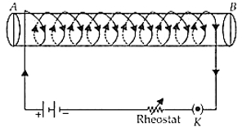  - When the plug of the key is closed, Where will the face Bof the iron bar be marked?  - How we can find thenorth - south polarities of an electromagnet? | [3]
25 | Find the direction of magnetic field due to a current carrying circular coil held:  - Vertically in North - South plane and an observer looking it from East sees the current to flow in anti - clockwise direction.  - Vertically in East - West plane and an observer looking it from South sees the current to flow in anti - clockwise direction.  - Horizontally and an observer looking at it from below and see the current flowing in clockwise direction. | [3]
26 | - The diagram shows a bar magnet surrounded by four plotting compasses. Copy the diagram and mark the direction of the compass needle for each of the cases B, C and D. 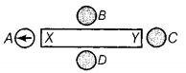  - Which is the North pole, X or Y? | [3]
27 | What is a Solenoid? Draw the pattern of the magnetic field lines around a current carrying solenoid. Mark on the pattern the region where the magnetic field is uniform. | [3]
28 | - Kanchi draws magnetic field lines of field close to the axis of a current carrying circular loop. As she moves away from the centre of the circular loop she observes that the lines keep on diverging. How will you explain her observation?  - Why does a magnetic compass needle pointing North and South in the absence of a nearby magnet get deflected when a bar magnet or a current carrying loop is brought near it? | [3]
29 | - Kanchi draws magnetic field lines of field close to the axis of a current carrying circular loop. As she moves away from the centre of the circular loop she observes that the lines keep on diverging. How will you explain her observation?  - A circuit has a fuse of 5 A. What is the maximum number of 100 watt (220 V) bulbs which can be safely used in the circuit? | [3]
30 | Draw magnetic field lines around a bar magnet? Give one point of difference between uniform and non - uniform magnetic field. | [3]
31 | - Draw the pattern of magnetic field lines produced by a current carrying circular loop showing the direction of current in the loop and the direction of the magnetic field lines.  - State the rule which can be applied to know the direction of magnetic field lines in the above case. | [3]
32 | A current - carrying wire produces a magnetic field around it. The phenomena in which an electromotive force and current (if the conductor is in the form of a closed circuit) is induced by changing magnetic field (or by passing magnetic field lines) through it is called electromagnetic induction. 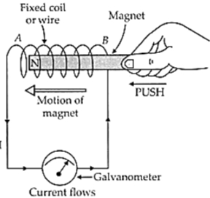  - What is the condition of electromagnetic induction?  - An induced emf is produced when a magnet is plunged into a coil. The magnitude of induced emf does not depend? | [3]
33 | An electron beam enters a magnetic field at right angles to it as shown in the figure. 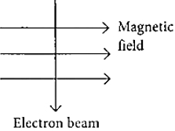  - What will be the direction of force acting on the electron beam?  - If a changed particle is moving along the magnetic field line. What will be the magnetic force on the particle? | [3]
34 | In activity shown, how do you think the displacement of rod AB will be affected 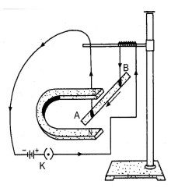  - if the current in rod AB is increased  - a stronger horse shoe magnet is used | [3]
35 | - An electric heater is rated at 2 kW. Electrical energy costs$₹$ 4 per kWh. What is the cost of using the heater for 5 hours?  - Consider a circular loop of wire lying in the plane of the table. Let the current pass through the loop clockwise. Apply right - hand rule to find out the direction of the magnetic field inside and outside the loop. | [3]
36 | The flow of current in a circular wire creates a magnetic field at its centre. How can existence of this field be detected? State the rule which helps to predict the direction of magnetic field. | [3]
37 | A magnetic compass needle is placed in the plane of paper near point A as shown in the figure. 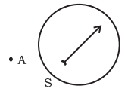  - In which plane should a straight current - carrying conductor be placed so that it passes through A and there is no change in the deflection of the compass?  - Under what condition is the deflection maximum and why? | [3]
38 | Mahesh bought an electric iron and connected its wires into the two - pin plug. Obviously, the green wire was not connected anywhere. Few days later, his wife got a severe electric shock while ironing the clothes. The electrician told Mahesh that this situation could be averted, if he had connected the green wire also, using the three - pin plug. Mahesh learnt a lesson for a life - time.Read the above passage and answer the following questions:  - Which terminal was to be connected using green wire?  - What qualities does Mahesh need to incorporate in himself to avoid such mistakes?  - If you were the electrician, what else would you do than explaining to Mahesh? | [3]
39 | Magnetic field lines of the field produced by a current - carrying circular loopare shown in the figure. 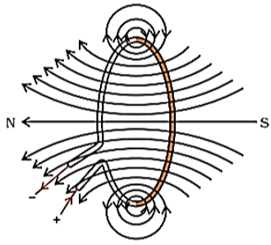  By analyzing the concept of magnetic field and magnetic field lines answer the following questions:  - How is the direction of the magnetic field at a point determined?  - What is the direction of the magnetic field at the centre of a current - carrying circular loop? | [3]
40 | A magnetic field is described by drawing the magnetic field lines. When a small north magnetic pole is placed in the magnetic field created by a magnet, it will experience a force. And if the north pole is free, it will move under the influence of the magnetic field. The path traced by a north magnetic pole free to move under the influence of a magnetic field is called a magnetic field line. 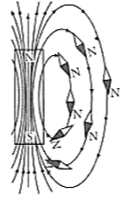  - Dothe magnetic field lines intersect each other? If not why?  - A strong bar magnet is placed vertically above a horizontal wooden board. What will be the magnetic lines of force? | [3]
41 | Under what conditions permanent electromagnet is obtained, if a current carrying solenoid is used? Support your answer with the help of a labelled circuit diagram. | [3]
42 | - State the direction of magnetic field in thefollowing case. 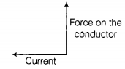  - How does the strength of magnetic field due to a current - carrying conductor depend upon  - distance from the conductor?  - current flowing through the conductor? | [3]
43 | - What are magnetic field lines? How is the direction of a magnetic field at a point determined? Mention two important properties of magnetic field lines.  - An electric oven of 2kW power rating is operated in a domestic electric circuit (220 V) that has a current rating of 5A. What result do you expect? Explain. | [3]
44 | An insulated copper wire wound on a cylindrical cardboard tube such that its length is greater than its diameter is called a solenoid. When an electric current is passed through the solenoid, it produces a magnetic field around it. The magnetic field produced by a current - carrying solenoid is similar to the magnetic field produced by a bar magnet. 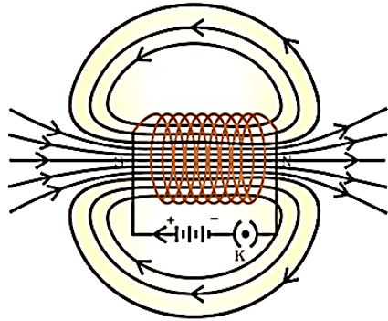  Field lines of the magnetic field through and around a current - carrying solenoid. 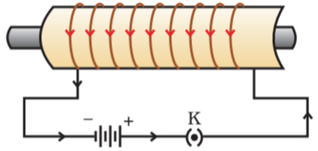  A current - carrying solenoid coil is used to magnetize steel rod inside it - an electromagnet.  - What will be the strength of the magnetic field inside a long current - carrying straight solenoid?  - A long solenoid carrying a current produces a magnetic field Balong its axis. If the current is double and the number of turns per cmis halved, then new value of magnetic field? | [3]
45 | - Consider a circular loop of wire lying in the plane of the table. Let the current pass through the loop in the clockwise direction. Apply right - hand rule to find out the direction of the magnetic field inside and outside the loop.  - Meena draws magnetic field lines of field close to the axis of a current carrying circular loop. As she moves away from the centre of the circular loop she observes that the lines keep on diverging. How will you explain her observation? | [3]

